**PUSL2010 Technology Justification**

**RANUL**

**Cloud Computing**

Today productivity and innovation in a business is a key, few years back cloud computing was an emerging technology but today, it’s being used by airlines, banks, IT companies and almost anywhere we see people use these cloud services from secured online meetings and transactions to personal movie entertainment. Today users are interacting with the cloud than ever before in fact statistics at the time writing show the data usage in a second is nearly 100,000 gigabytes that are made to the cloud. (Our World in Data, 2017)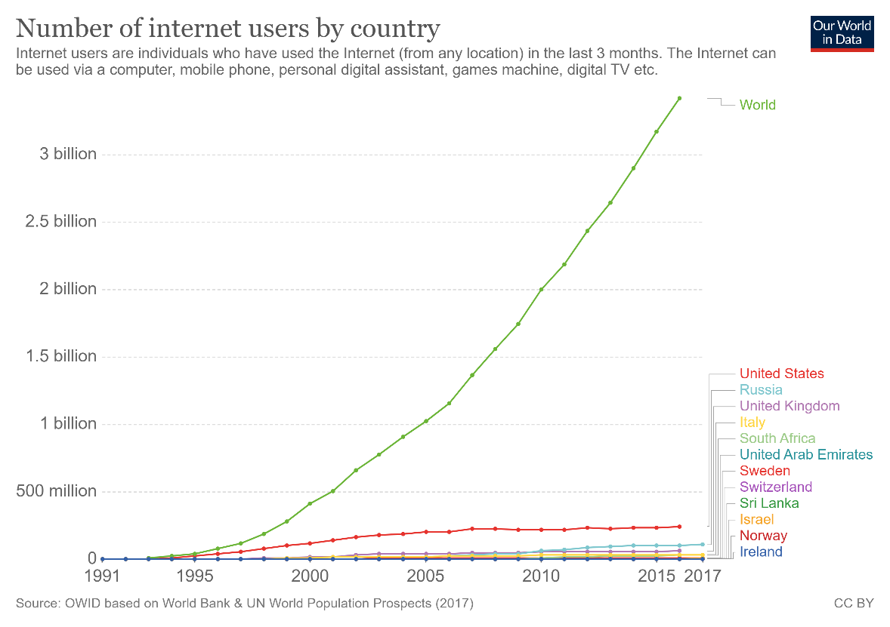

Figure : Graph of Number of Internet User (Our World in Data, 2017)

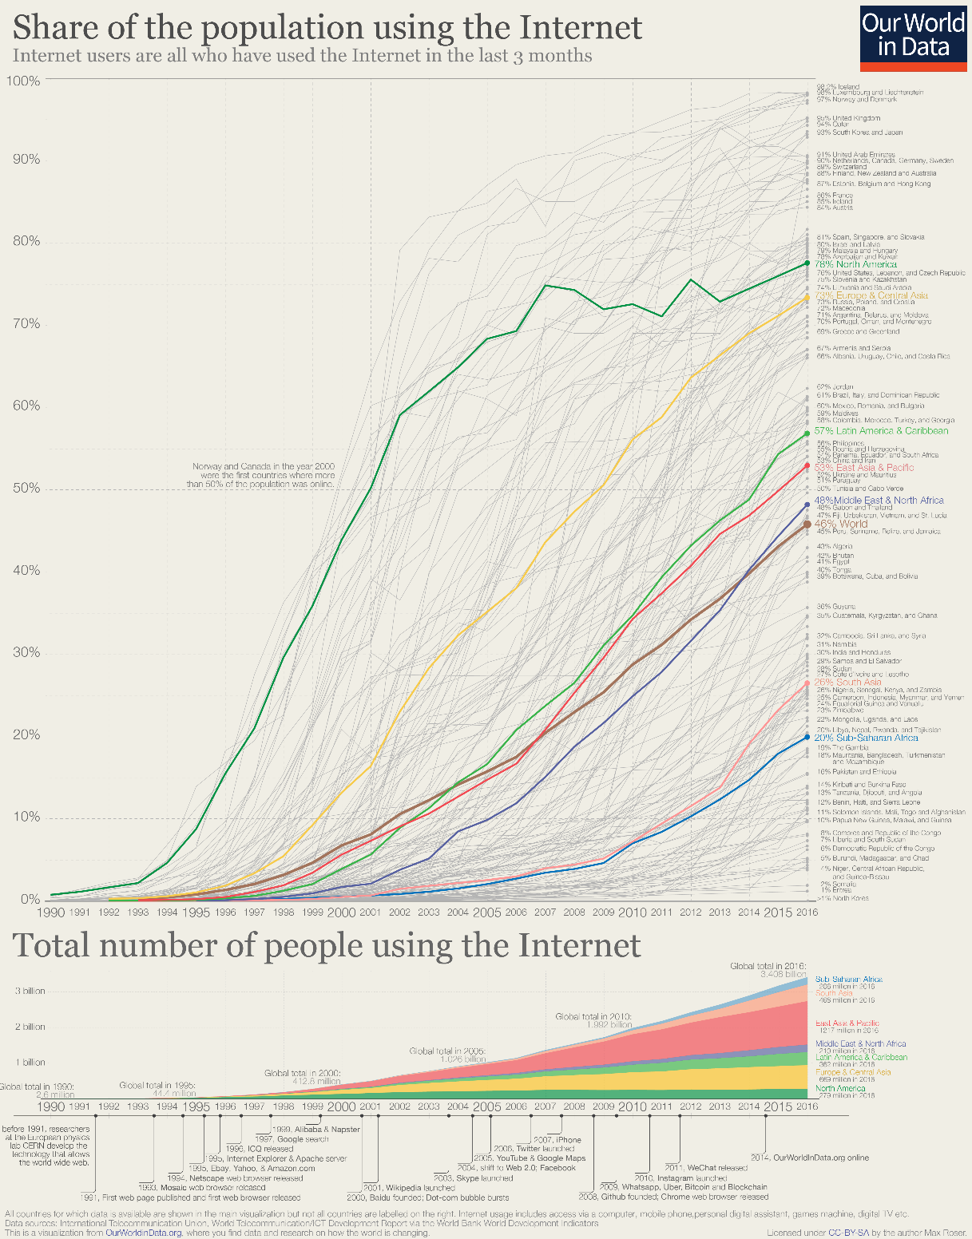

Figure : Figure 1: Graph of Number of Internet User in the World (Our World in Data, 2017)

**Types of cloud computing**

There are three types of services on a public cloud, private cloud or hybrid cloud.

**Public cloud**

Public clouds are provided by third party vendors to clients they offer these services usually for free or exceptionally low costs, all the software and hardware are managed by the vender and they allow client to access these resources over the internet virtually.

**Private cloud**

A private cloud usually is stored on a company’s premises for their business use only, this is comparatively costly compared to the method where vendors host the data on their private cloud offsite for low cost as they can virtualize and share resources.

**Hybrid cloud**

Hybrid clouds combine public and private clouds allowing much flexibility for access content within the private and public clouds, this allows a working officer to use the company’s public website to login securely to companies’ private resources with properly authentication. Most business use the hybrid cloud technology today.

**Types of Cloud Services**

**Infrastructure as a service (IaaS)**

IT infrastructure which includes servers, storage and other hardware are provide for a rental which make this a good choice for most entrepreneurs. i.e. AWS, Microsoft Azure

**Platform as a service (PaaS)**

Platform as a service offers the required hardware and software to be accessed online, similar IaaS but offer more flexibility on selecting a separate operating system and other hardware as platform for software without high level server management. i.e. Google App Engine

**Software as a service (SaaS)**

Software as a service allows users to access and use application using a web browser or similar tool by loading only required assets to the client end, this allows much flexibility and content can be access from any device that has web browsing. i.e. Office 365 Online, Jira, Github

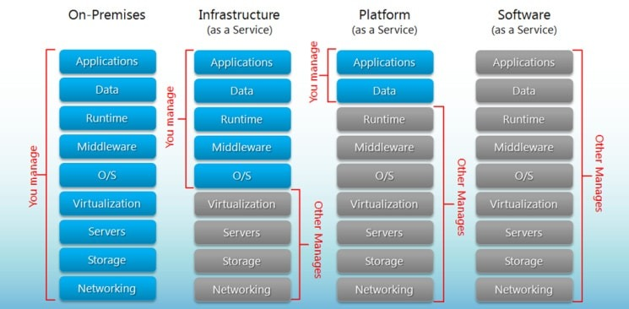

Figure :Comparison Illustration of Iaas, PaaS and SaaS (BigCommerce, 2020)

Advantages

* Cost Efficiency – Compared to traditional method implementation, maintenance and upgrading cost are exceptionally low. New cloud-based systems are very economical for both startups and large enterprises.
* Backup and Recovery – Data available on cloud allows to quickly restore data and failure rate is low as there are multiple servers to save copies of the same data.
* Storage – Cloud storage allows users to expand storage at very low costs compared to on premises storage disks, it saves costs on expanding building size for storage requirements and economical.
* Speed – Most services provide edge speeds with cloud storage, when they use SSDs but to be benefited by this technology customer should have an internet connection with a good bandwidth of at least 10MBps.
* Global Scale – Cloud systems are assessible from anywhere without extra costs and allows to integrate and work with multinationals with ease, in fact cloud services make little impact on client’s storage, processing power and bandwidth.
* Security – Most issuers supply a satisfactory level of privacy configuration and controls for management and connections are secured using network encryption and storage encryption.
* Performance and Reliability – Datacenters upgrade their components regularly which offers users the best in class experience with their service. With new implementation plans there is less downtimes and slow down as data is accessible from multiple datacenters around the globe.
* Productivity – Deployment of services could be done within few hours compared to on premises storage that usually take weeks to get configured in most cases.

Disadvantages

* Security – There’s considerable risk of data theft when selecting cloud storage as the IT infrastructure of a business in the past, confidential data and financial records have been compromised.
* Network – In order to be benefited clients need have an active network connection and an above average bandwidth to keep a constant connection with the service.
* Technical – There can issues as servers are prone to DDoS attacks and suffer downtime, sometimes even cloud services suffer from internet and power issues which effects client’s business as they have limited functionalities to manage the cloud.
* Vendor Lock-in – Migrating from on cloud service to another is not flexible but new services are being built to mitigate these limitations such as cluster sharing that are provided by SQL Server.
* Support – Communications between the cloud provider and client takes time usually emails take 2 working days or weeks for a response on busy weeks this isn’t acceptable for most businesses.

Cloud computing offers both advantages and risks to a business if not properly implemented, considering all facts it would be better to store highly confidential static data on premises and other data on the cloud which requires regular interactions.

**Bibliography**

[Apostu, A. (2013) 'Study on advantages and disadvantages of Cloud Computing – the advantages of Telemetry Applications in the Cloud', *Recent Advances in Applied Computer Science and Digital Services*, Economic Informatics and Cybernetics Department Academy of Economic Studies 15-17, Calea DorobanŃi, Bucharest 4, University POLITEHNICA of Bucharest ROMANIA.](https://pdfs.semanticscholar.org/ada5/876e216130cdd7ad6e44539849049dd2de39.pdf)

**References**

Hou, T. (2020) 'IaaS vs PaaS vs SaaS Enter the Ecommerce Vernacular: What You Need to Know, Examples & More', *BIGCOMMERCE*, 9 April. Available at: <https://www.bigcommerce.com/blog/saas-vs-paas-vs-iaas/#the-key-differences-between-on-premise-saas-paas-iaas> (Accessed: 09 April 2020).

Our World in Data (2017) *Internet*. Available at: <https://ourworldindata.org/internet>

 (Accessed: 08 April 2020).